Contour Line Project
Objective: To create a composition using only lines to create depth and form.

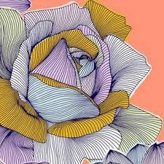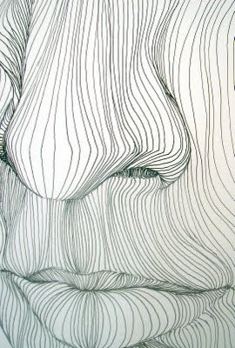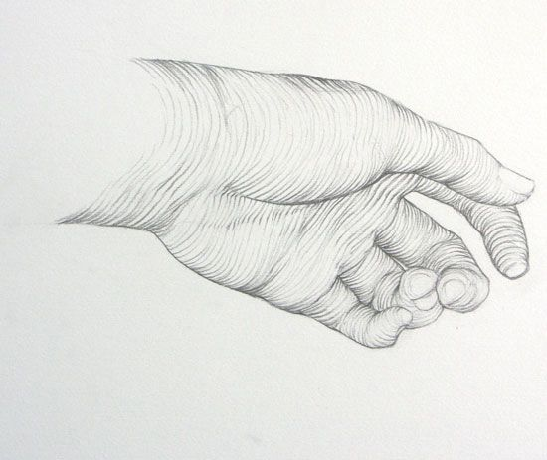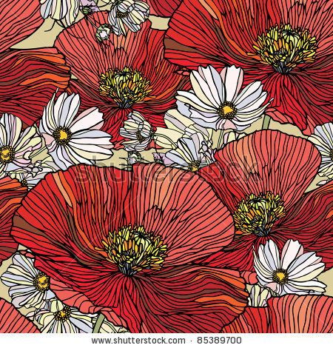

Creating Process:
Step 1: Find an image that could be used for this project. You want to find an image that is cropped or zoomed in on so you are focusing on a smaller area rather than a full area of a picture.
Step 2: Print multiple ideas and bring back to Mrs. Granberg
Step 3: Once image is approved by Mrs. Granberg you may begin to sketch out the outline of your image on a sheet of paper given to you by Mrs. Granberg.
Step 4: When drawing your contour lines really think about how the line should be placed on the paper, it the line completely striaght or does it have curves in it? This will help create more depth in your drawing. This is something I will be checking for and grading you on.
Step 5: Watercolor-You will be painting these with watercolors first and then tracing over all lines with sharpie when complete.
***Any questions make sure you ask! Have fun and create some great artwork!

